Stock Screen

**First screen will be display grid . Pop-up screen is for adding new record or modify existing record or delete record.**

What ever i marked in red crossed are not required to develop instead we want better search option. which i have given in second page and u can check below link

http://download.oracle.com/otn_hosted_doc/jdeveloper/11gdemos/adffacesruntime/adffacesruntime.htm

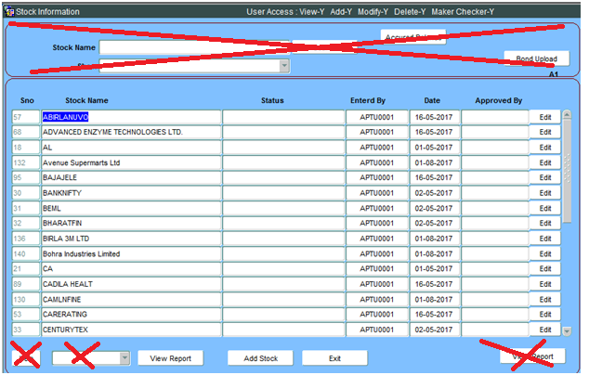

I want grid and search options like below screen or U can suggest if u have better option.

in below screen user can add column or hide column , move columns , Export data to excel .

We need Edit Button in each line when user click edit button it should open pop up and show the data to modify or delete data

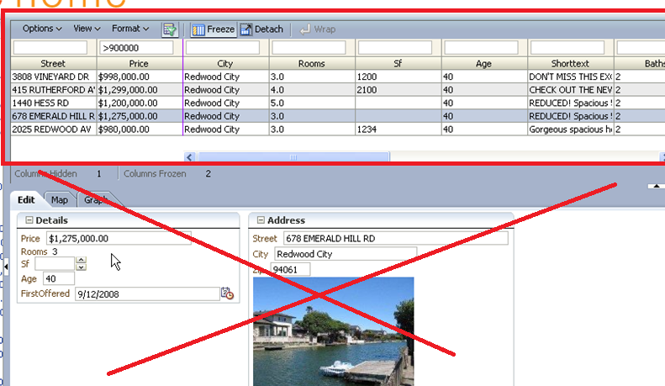

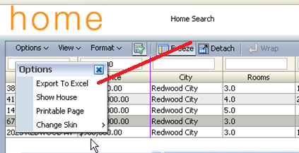

When user click Add Stock or Edit button in the first grid. It should open pop same as below screen and allow user to add data or modify data

Below screen is master details .

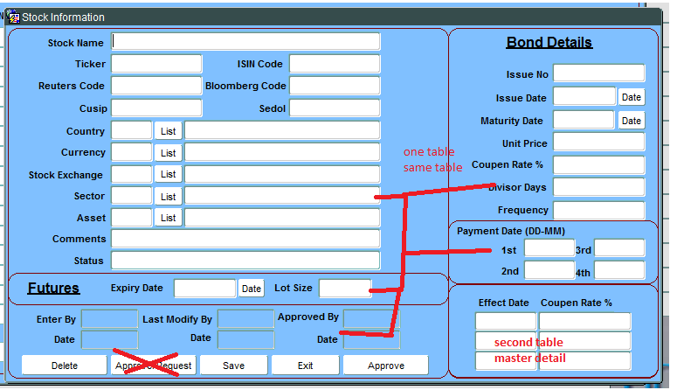

Approve button : When user click approve button it should check user who logged in user and in this screen Enter by user should not be same, if it same it should give message 'You can not approve, Contact IT Dept'. If both user are different then update Status field with ' Approved' and Approved by with the userid who logged , date =sysdate.

Save Button : it should save the record. While saving time it should update WMS_PRODUCT_ID with serial number. It should update Enterby , Last Modify By , Date also with the logged userid ( Incase record is Approved then user should not be allowed to modify data'

Delete Button : It Should delete the record . ( Incase record is Approved then user should not be allowed to delete data)

Master Table FWMS_PRODUCT

DETAIL TABLE FWMS_BOND_COUPEN

Link between both table is wms_product_id master and WMS_BOND Details table

For List box Country,Currency,Exchagne,Asset ,Sector i have given table details

